Texture References:

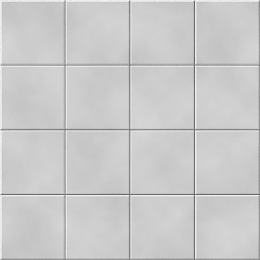

Maehring, M. (2019). *tiles*. [image] Available at: https://www.pinterest.com.mx/pin/292874782010949746/?lp=true [Accessed 8 May 2019].

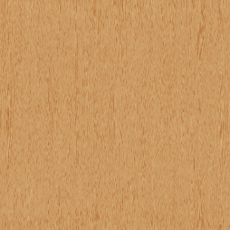

Domagala. (2019). *Wood texture*. [image] Available at: https://www.pinterest.co.uk/pin/478929741617059600/?lp=true [Accessed 8 May 2019].

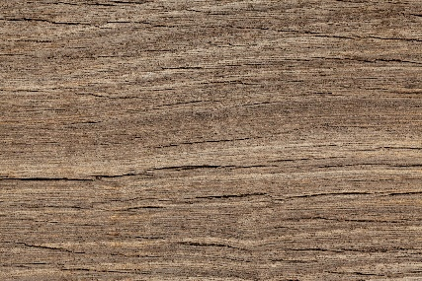

Kratochvil, P. (2019). *Wood Texture*. [image] Available at: https://www.publicdomainpictures.net/en/view-image.php?image=25761&picture=wood-texture [Accessed 8 May 2019].

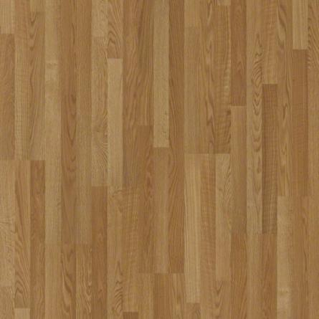

Carpet and Rug Inc (2019). *Color: Big Bend Oak*. [image] Available at: https://www.carpetsindalton.com/products/hard-surfaces/laminate-flooring/natural-values-ii-by-shaw-laminate [Accessed 8 May 2019].



UK Hide (2019). *Lady K0022 Violet*. [image] Available at: https://www.ukhide.co.uk/product/lady-k0022-violet/ [Accessed 8 May 2019].

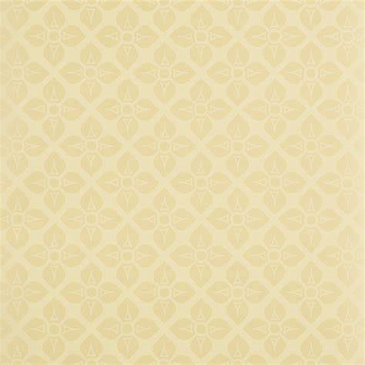

Zoffany (2019). *Zoffany Patterned Floral Design Vinyl Kitchen and Living Room Wallpaper Roll*. [image] Available at: https://www.manomano.co.uk/catalogue/p/zoffany-wallpaper-roll-yellow-beige-floral-patterned-vinyl-acv04003-2613648?categorySlug=wallpaper&product_id=2654284 [Accessed 8 May 2019].